Regional difference in the susceptibility of non-alcoholic fatty liver disease in China

**Supporting Information**

Table S1. Participants and proportion of NAFLD by province/municipality

|  |  |  |  |
| --- | --- | --- | --- |
| Province/municipality | Number of participants | Number of NAFLD patients | Crude proportion of NAFLD (%) |
| Shanghai (3 centers) | 967 | 337 | 34.9% |
| Jiangsu (2 centers) | 262 | 102 | 38.9% |
| Henan (1 center) | 287 | 106 | 36.9% |
| Tianjin (2 centers) | 493 | 234 | 47.5% |
| Shandong (1 center) | 137 | 96 | 70.1% |
| Heilongjiang (1 center) | 274 | 175 | 63.9% |

Table S2. The phantom’s hepatic echo-intensity attenuation rate and hepatic/renal echo-intensity ratio after machine calibration

|  |  |  |  |  |  |
| --- | --- | --- | --- | --- | --- |
| Province/  region | Hospital | Machine manufacturer | Type | Phantom’s hepatic attenuation rate (MHz-1∙cm-1) | Phantom’s hepatic/renial ratio |
| Shanghai |  |  |  |  |  |
|  | Zhongshan Hospital, Fudan University | GE | Logiq P5 | 0.01051 | 1.822498 |
| GE | Vivid 7 | 0.00901 | 1.731785 |
|  | The Sixth People's Hospital Affiliated to Shanghai Jiaotong University | GE | Logiq S8 | 0.01295 | 1.817411 |
|  | Ruijin Hospital Affiliated to Shanghai Jiaotong University | GE | Logiq C5 | 0.01195 | 1.825181 |
| Jiangsu |  |  |  |  |  |
|  | The Affiliated Drum Tower Hospital of Nanjing University Medical School | GE | Logiq 7 | 0.01197 | 1.739428 |
|  | Zhongda Hospital Affiliated to Southeast University Medical School | GE | Logiq P5 | 0.01477 | 1.716790 |
| Henan |  |  |  |  |  |
|  | The First Affiliated Hospital of Zhengzhou University | GE | Vivid7 | 0.01123 | 1.806951 |
| Tianjin |  |  |  |  |  |
|  | The Third Central Hospital of Tianjin | GE | Logiq E9 | 0.01054 | 1.813775 |
|  | Metabolic Disease Hospital of Tianjin Medical University | GE | Logiq L7 | 0.01034 | 1.806608 |
| Shandong | Affiliated Hospital of Qingdao University Medical College | Phillips | IU 22 | 0.01264 | 1.848821 |
| Heilongjiang | The Second Affiliated Hospital of Harbin Medical University | GE | Logiq P5 | 0.01132 | 1.732355 |
| CV(%) |  |  |  | 13.4% | 2.6% |
| CV, coefficient of variation. | | | | | |

|  |  |  |  |  |  |  |
| --- | --- | --- | --- | --- | --- | --- |
| Table S3. Comparison of NAFLD concomitant rates under different glucose metabolism status between non-drinkers in South and North group. | | | | | | |
|  | No. of NAFLD | NAFLD prevalence (%) | OR (95%CI) | | | |
| Unadjusted | Model 1 | Model 2 | Model 3 |
| All participants (N=1910) | | | | | | |
| Total | 814 | 42.62% | - | - |  | - |
| South | 475 | 36.43% | 1(Ref) | 1(Ref) | 1(Ref) | 1(Ref) |
| North | 339 | 55.94% | 2.22(1.82-2.70) | 1.96(1.53-2.53) | 2.91(2.14-3.97) | 2.54(1.86-3.50) |
| P value |  |  | <0.001 | <0.001 | <0.001 | <0.001 |
| NGT (N=610) | | | | | | |
| Total | 148 | 24.26% | - | - | - | - |
| South | 72 | 17.56% | 1(Ref) | 1(Ref) | 1(Ref) | 1(Ref) |
| North | 76 | 38.00% | 2.88(1.96-4.22) | 2.85(1.86-4.40) | 4.08(2.45-6.91) | 4.09(2.33-7.33) |
| P value |  |  | <0.001 | <0.001 | <0.001 | <0.001 |
| IGR (N=329) | | | | | | |
| Total | 145 | 44.07% | - | - | - | - |
| South | 82 | 35.19% | 1(Ref) | 1(Ref) | 1(Ref) | 1(Ref) |
| North | 63 | 65.62% | 3.52(2.15-5.84) | 3.12(1.84-5.36) | 6.23(3.25-12.40) | 5.33(2.71-10.93) |
| P value |  |  | <0.001 | <0.001 | <0.001 | <0.001 |
| T2DM (N=971) | | | | | | |
| Total | 521 | 53.66% | - | - | - | - |
| South | 321 | 48.56% | 1(Ref) | 1(Ref) | 1(Ref) | 1(Ref) |
| North | 200 | 64.52% | 1.93(1.46-2.55) | 1.81(1.36-2.41) | 2.75(1.93-3.95) | 2.46(1.71-3.56) |
| P value |  |  | <0.001 | <0.001 | <0.001 | <0.001 |
| Multivariate logistic regression models were gradually adjusted for:  Model 1 was adjusted for age, gender and cigarette smoking.  Model 2 was adjusted for BMI, WC, FBG, SBP, TG, TC, LDL-c, HDL-c, UA and statins treatment in addition to factors included in model 1.  Model 3 was adjusted for ALT, AST, GGT in addition to factors included in model 2.  Abbreviations: OR, odds ratio, 95%CI, 95% confidence interval. NAFLD, nonalcoholic fatty liver disease; NGT, normal glucose tolerance; IGR, impaired glucose regulation; T2DM, type 2 diabetes mellitus; BMI, body mass index; WC, waist circumference; FBG, fasting blood glucose; SBP, systolic blood pressure; TG, triglyceride; TC, total cholesterol; LDL-c, low density lipoprotein cholesterol; HDL-c, high density lipoprotein cholesterol; UA, uric acid; ALT, alanine aminotransferase; AST, aspartate aminotransferase; GGT, gamma-glutamyl transferase. | | | | | | |

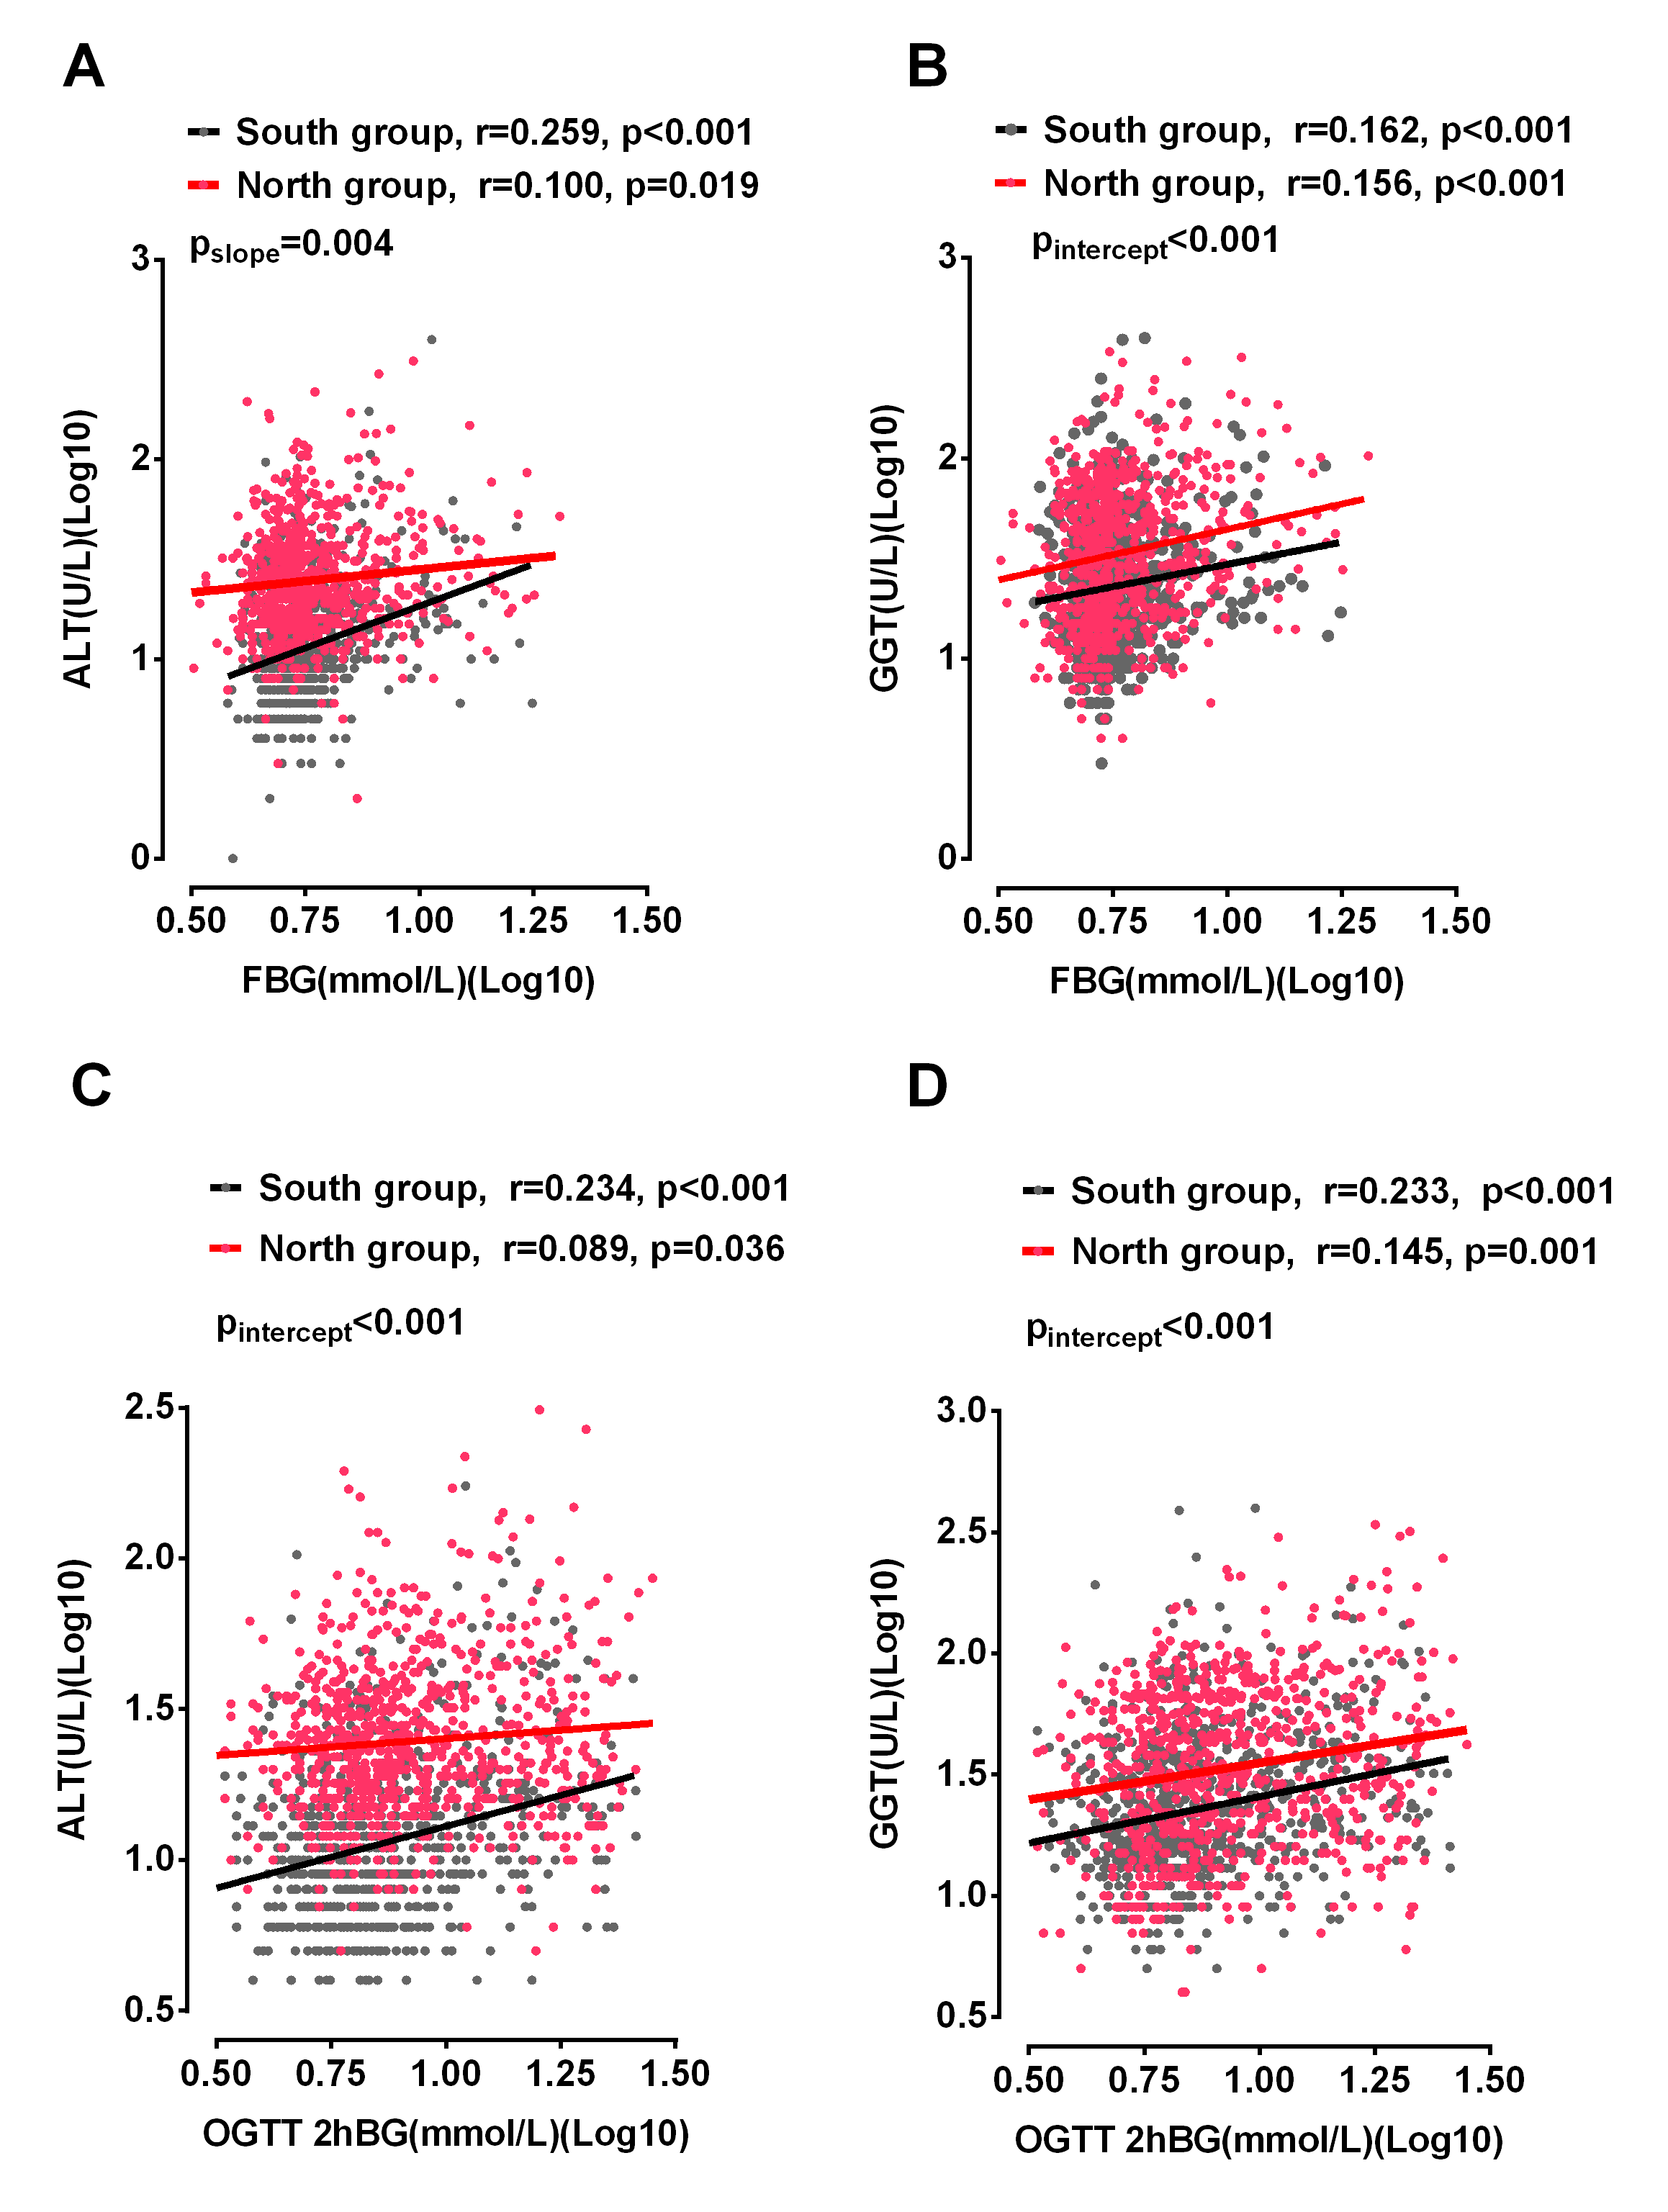

**Supplementary Figure 1**. **Relationships of serum ALT and GGT with FBG, OGTT 2hBG in participants without previous antidiabetic treatment.** Participants from Henan province were included in the South group based on their metabolic features and genetic structure. ALT and GGT were positively associated with FBG (A, B) and OGTT 2hBG (C, D) in participants from both North and South groups (all p<0.05). The participants from the North group had significantly higher serum ALT than the participants from the South with similar level of FBG, and the difference was reduced with increasing FBG (pslope= 0.004). The serum ALT at any given level of OGTT 2hBG and serum GGT at any given level of FBG and OGTT 2hBG was significantly higher in the North group comparing to the South group (all p<0.001). Black dots and lines represent participants from the South group. Red dots and lines represent participants from the North group. Abbreviations: ALT, alanine aminotransferase; FBG, fasting blood glucose; GGT, gamma-glutamyl transferase; OGTT 2hBG, 2-hour postload blood glucose in oral glucose tolerance test.

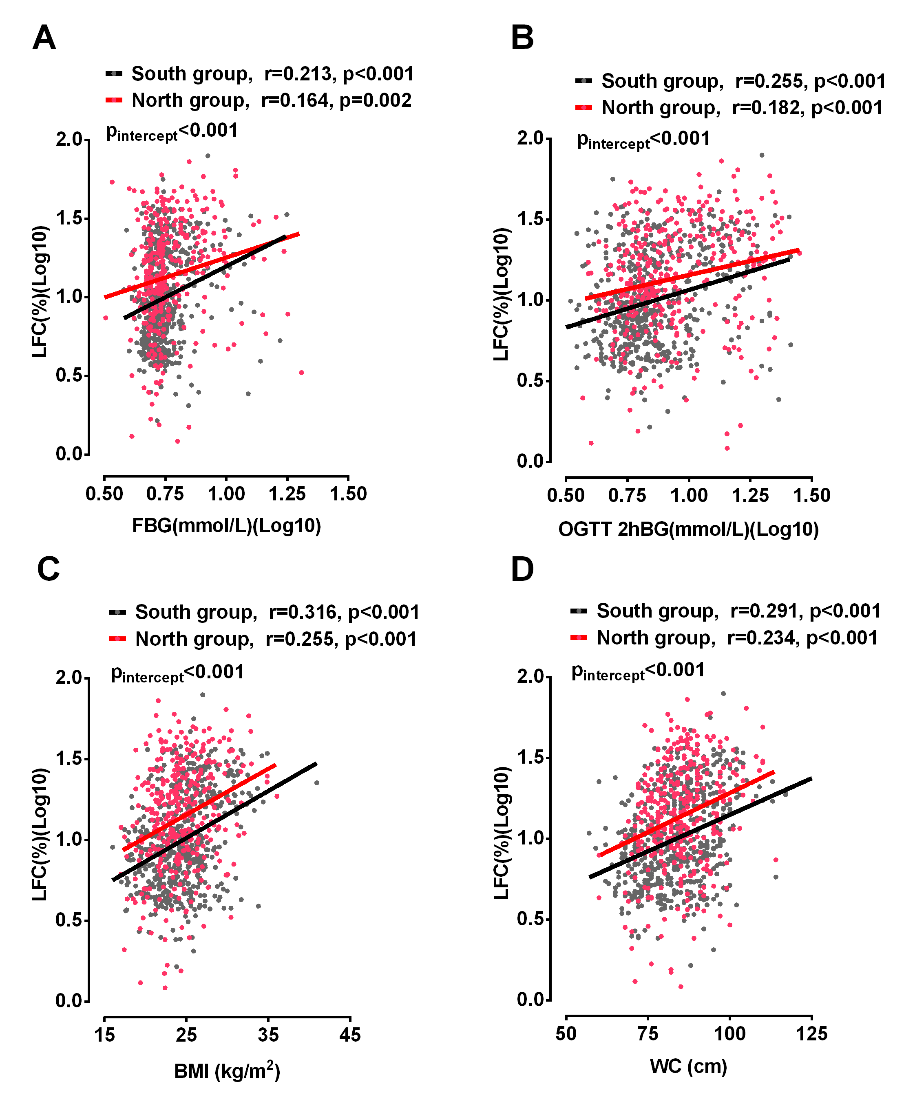

**Supplementary Figure 2. Relationships of LFC (%) with FBG (A), OGTT 2hBG (B), BMI (C), WC (D) in participants without previous antidiabetic treatment and without alcohol consumption.** Participants from Henan province were included in the South group based on their metabolic features and genetic structure. LFC was positively associated with FBG, OGTT 2hBG, BMI and WC in participants from both North and South groups (all p<0.05). Northern Han Chinese had significantly higher LFCs than Southern Han Chinese at any given level of FBG, OGTT 2hBG, BMI or WC. Black dots and lines represent participants from the South group. Red dots and lines represent participants from the North group. Abbreviations: BMI, body mass index; WC, waist circumference; FBG, fasting blood glucose; LFC, liver fat content; OGTT 2hBG, 2-hour postload blood glucose in oral glucose tolerance test.

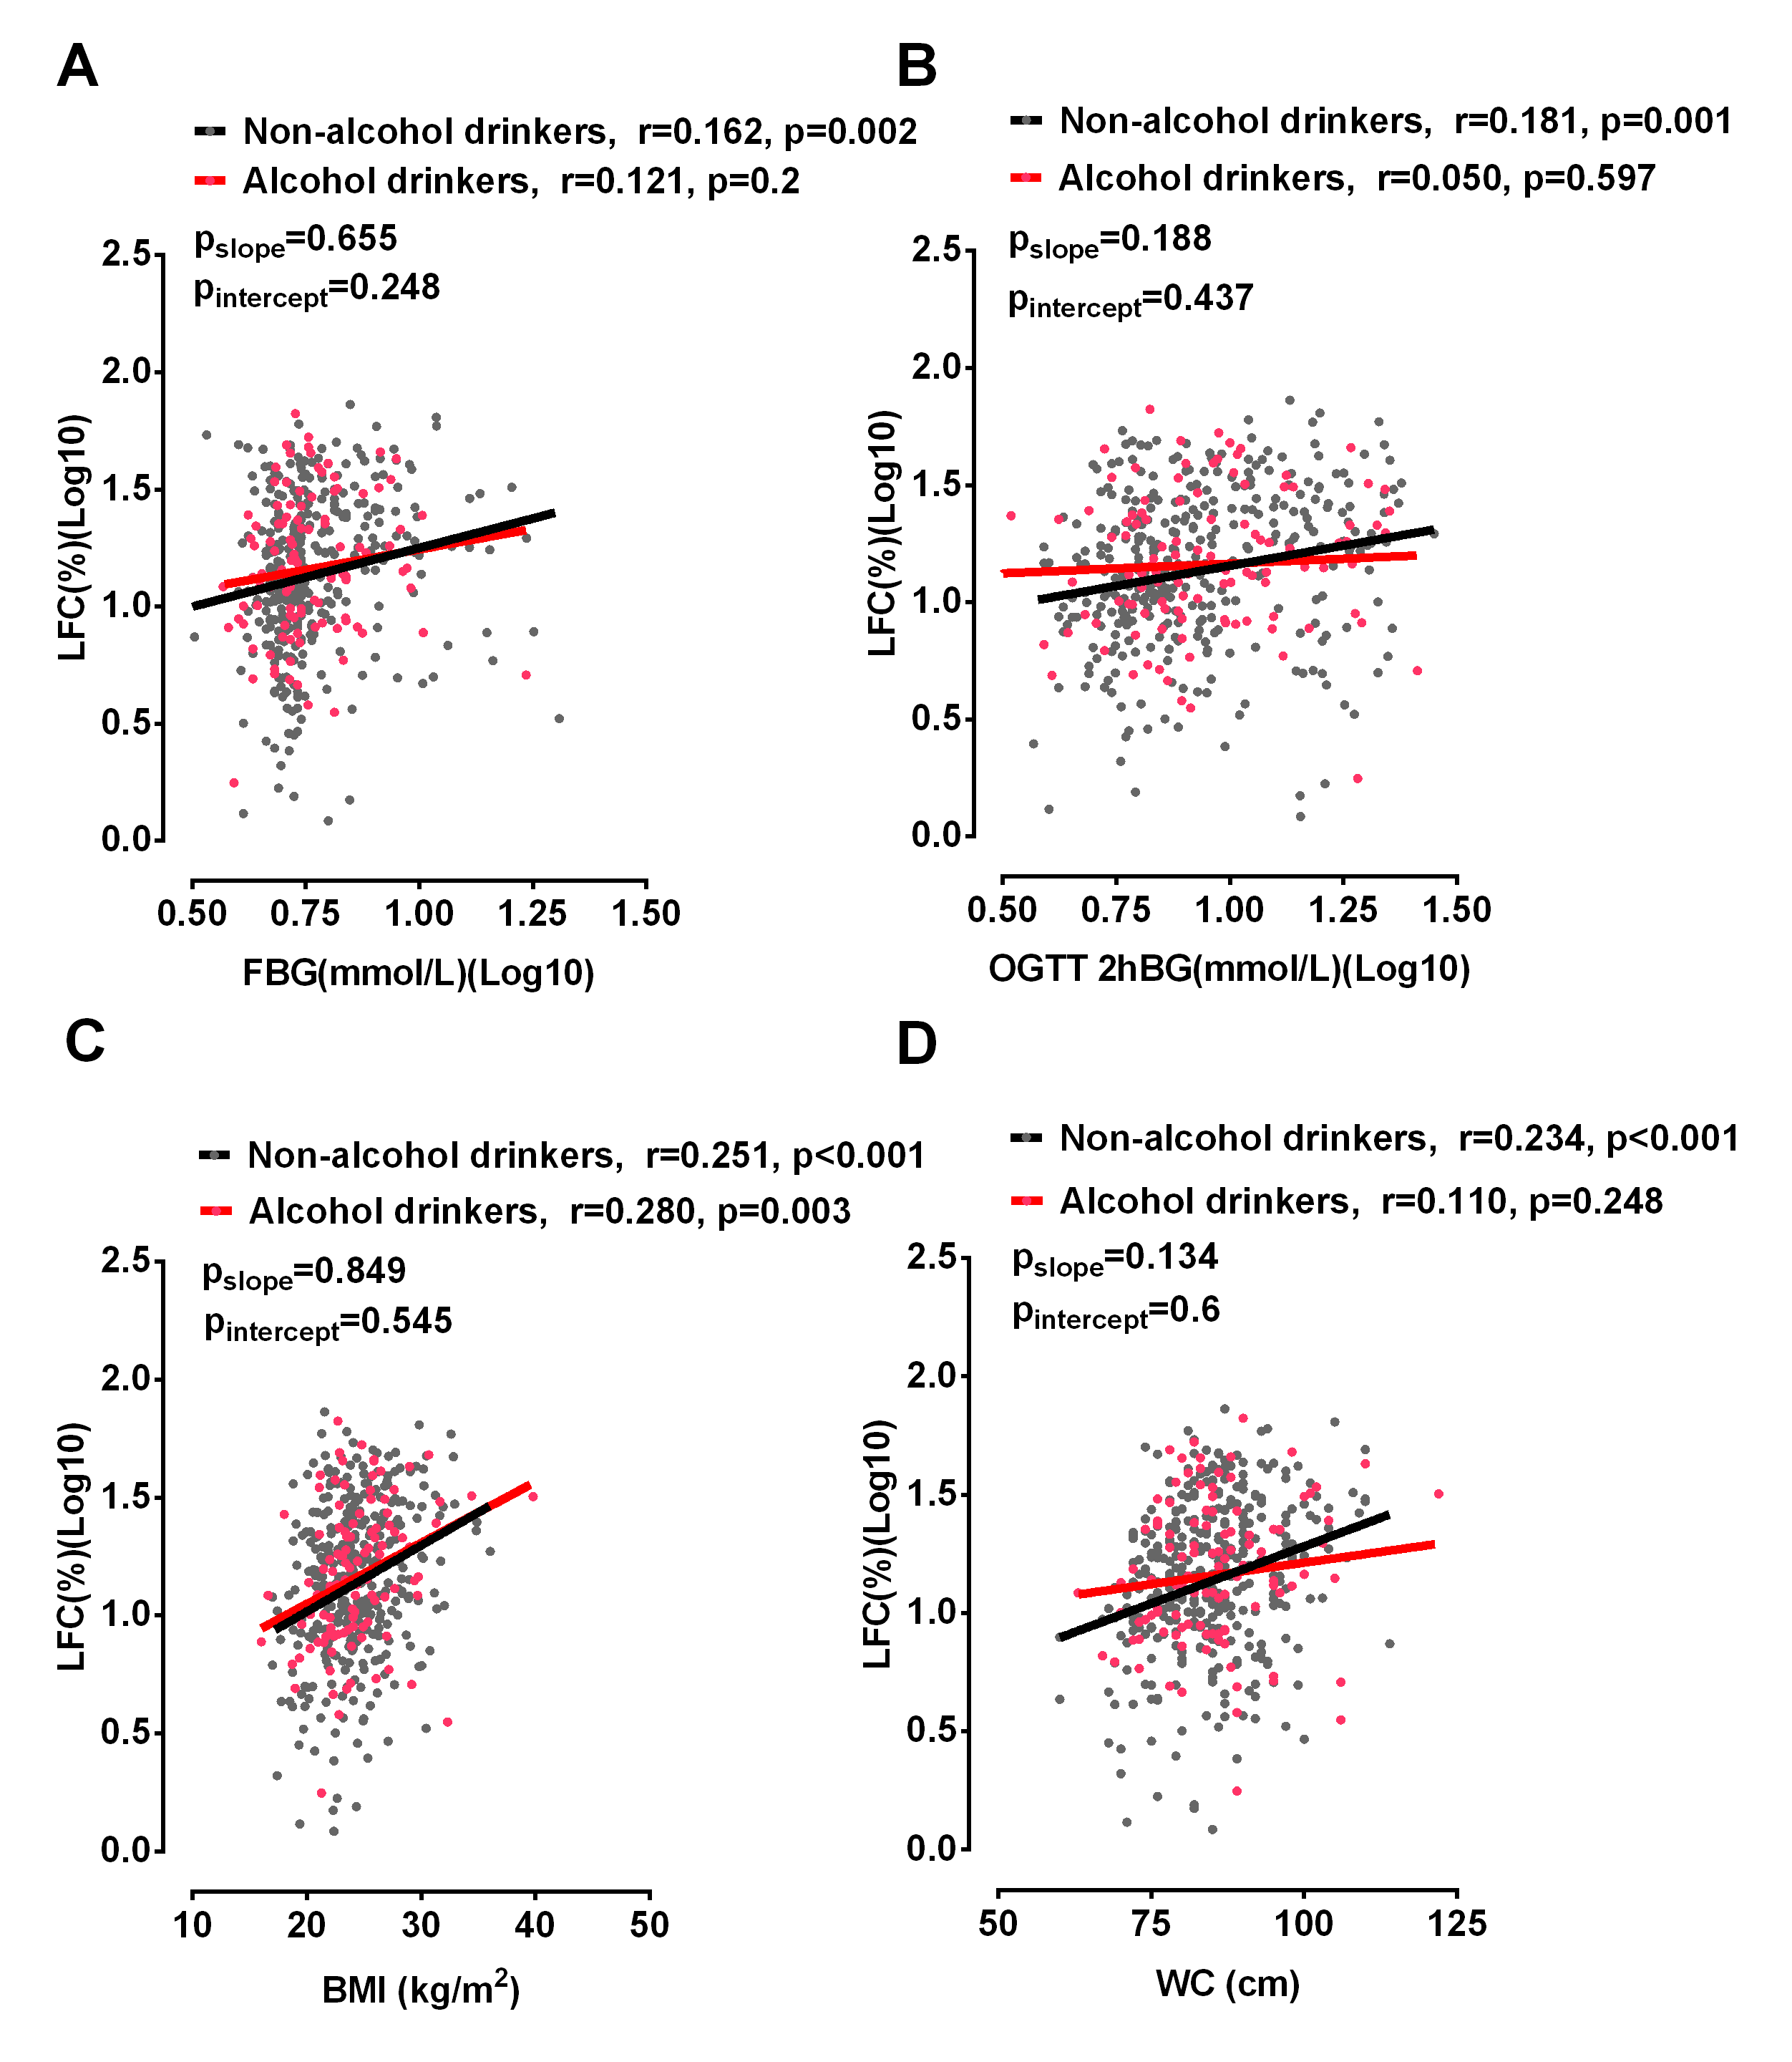

**Supplementary Figure 3. Relationships of LFC (%) with FBG (A), OGTT-2hBG (B), BMI (C) and WC (D) in alcohol drinkers and non-drinkers without previous antidiabetic treatment from the North group (Tianjin, Shandong and Heilongjiang Province).** There were no differences in the slopes or the intercepts of the regression lines relating FBG, OGTT 2hBG, BMI and WC to LFC between alcohol drinkers and non-drinkers (p >0.05). Black dots and lines represent non-drinkers. Red dots and lines represent alcohol drinkers. Abbreviations: BMI, body mass index; WC, waist circumference; FBG, fasting blood glucose; LFC, liver fat content; OGTT 2hBG, 2-hour postload blood glucose in oral glucose tolerance test.

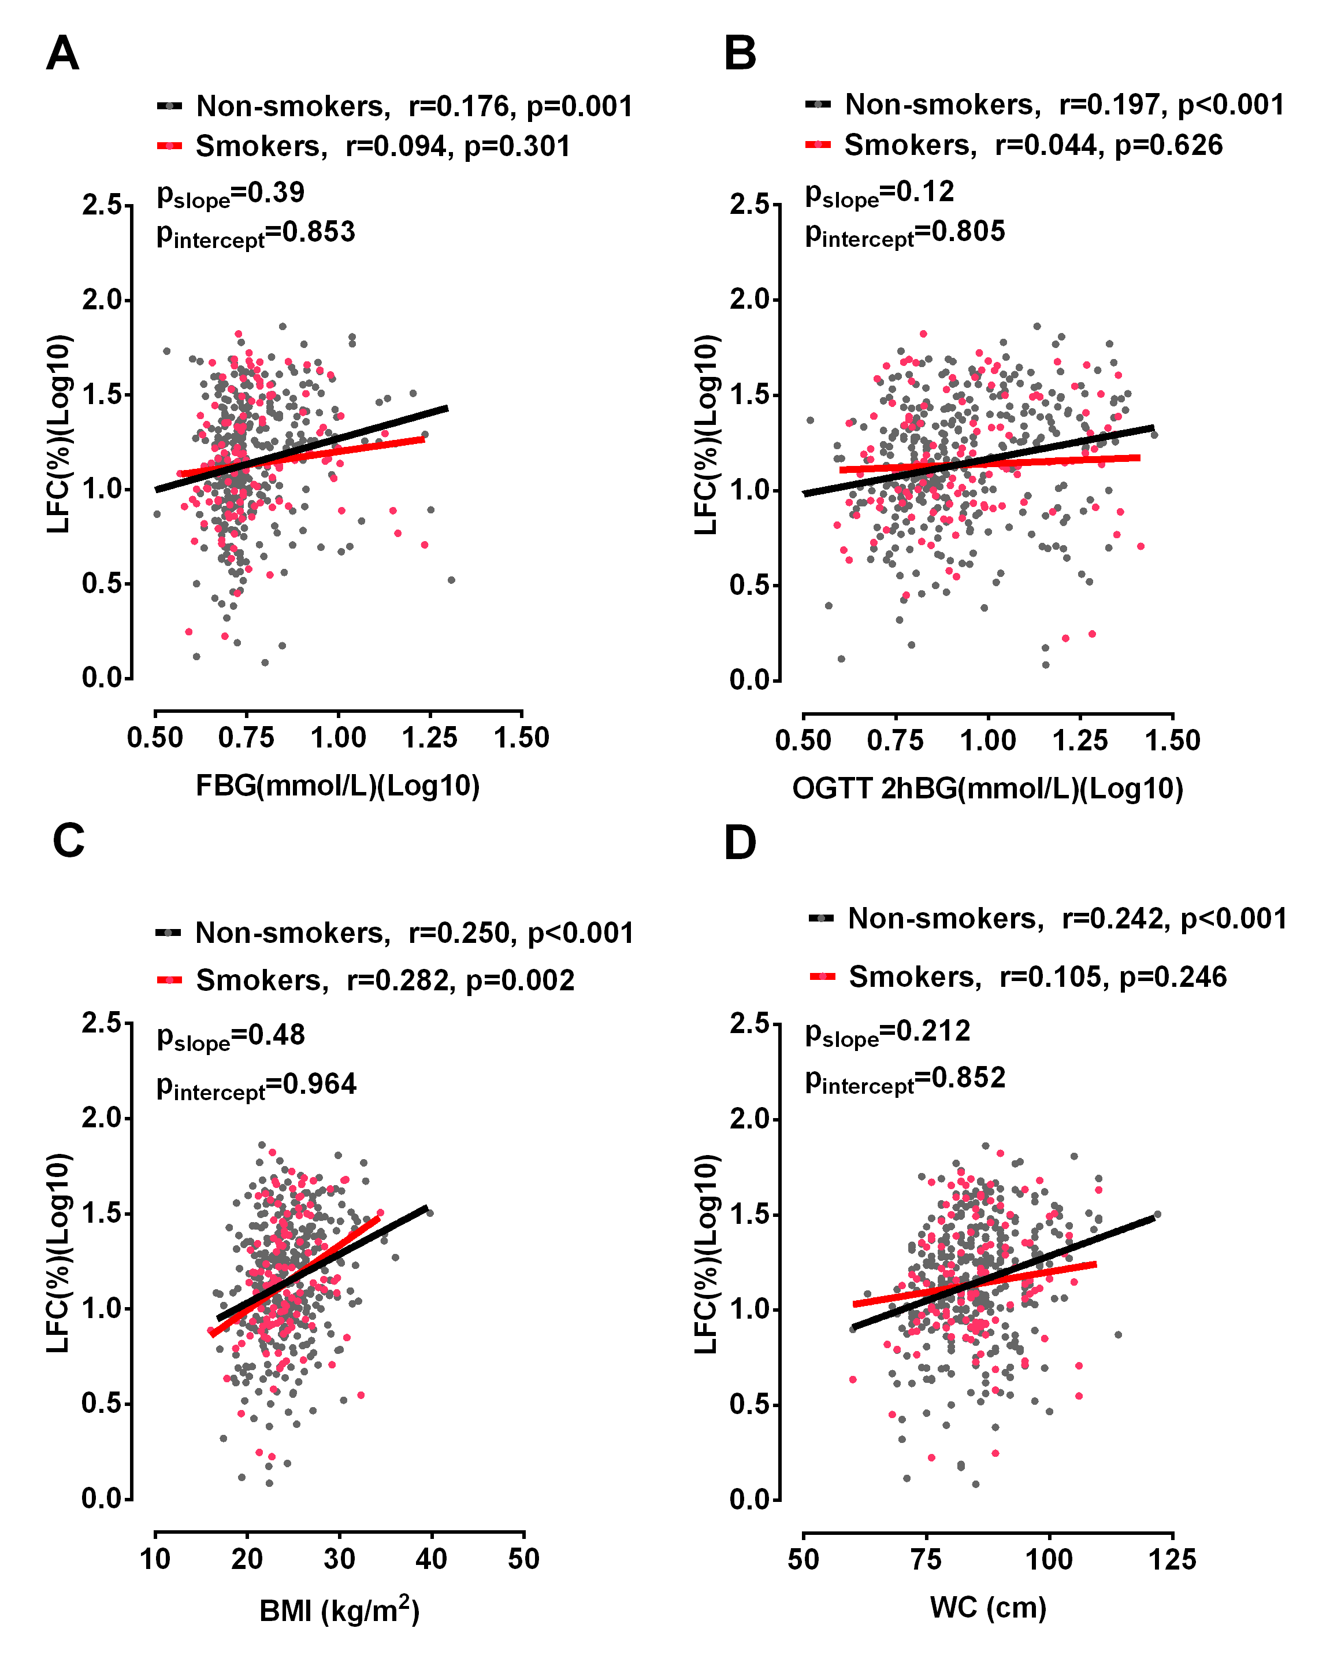

**Supplementary Figure 4. Relationships of LFC (%) with FBG (A), OGTT-2hBG (B), BMI (C) and WC (D) in smokers and non-smokers without previous antidiabetic treatment from the North group (Tianjin, Shandong and Heilongjiang Province).** There were no differences between the slopes or the intercepts of the regression lines relating FBG, OGTT 2hBG, BMI and WC to LFC (p >0.05). Black dots and lines represent non-smokers. Red dots and lines represent smokers. Abbreviations: BMI, body mass index; WC, waist circumference; FBG, fasting blood glucose; LFC, liver fat content; OGTT 2hBG, 2-hour postload blood glucose in oral glucose tolerance test.

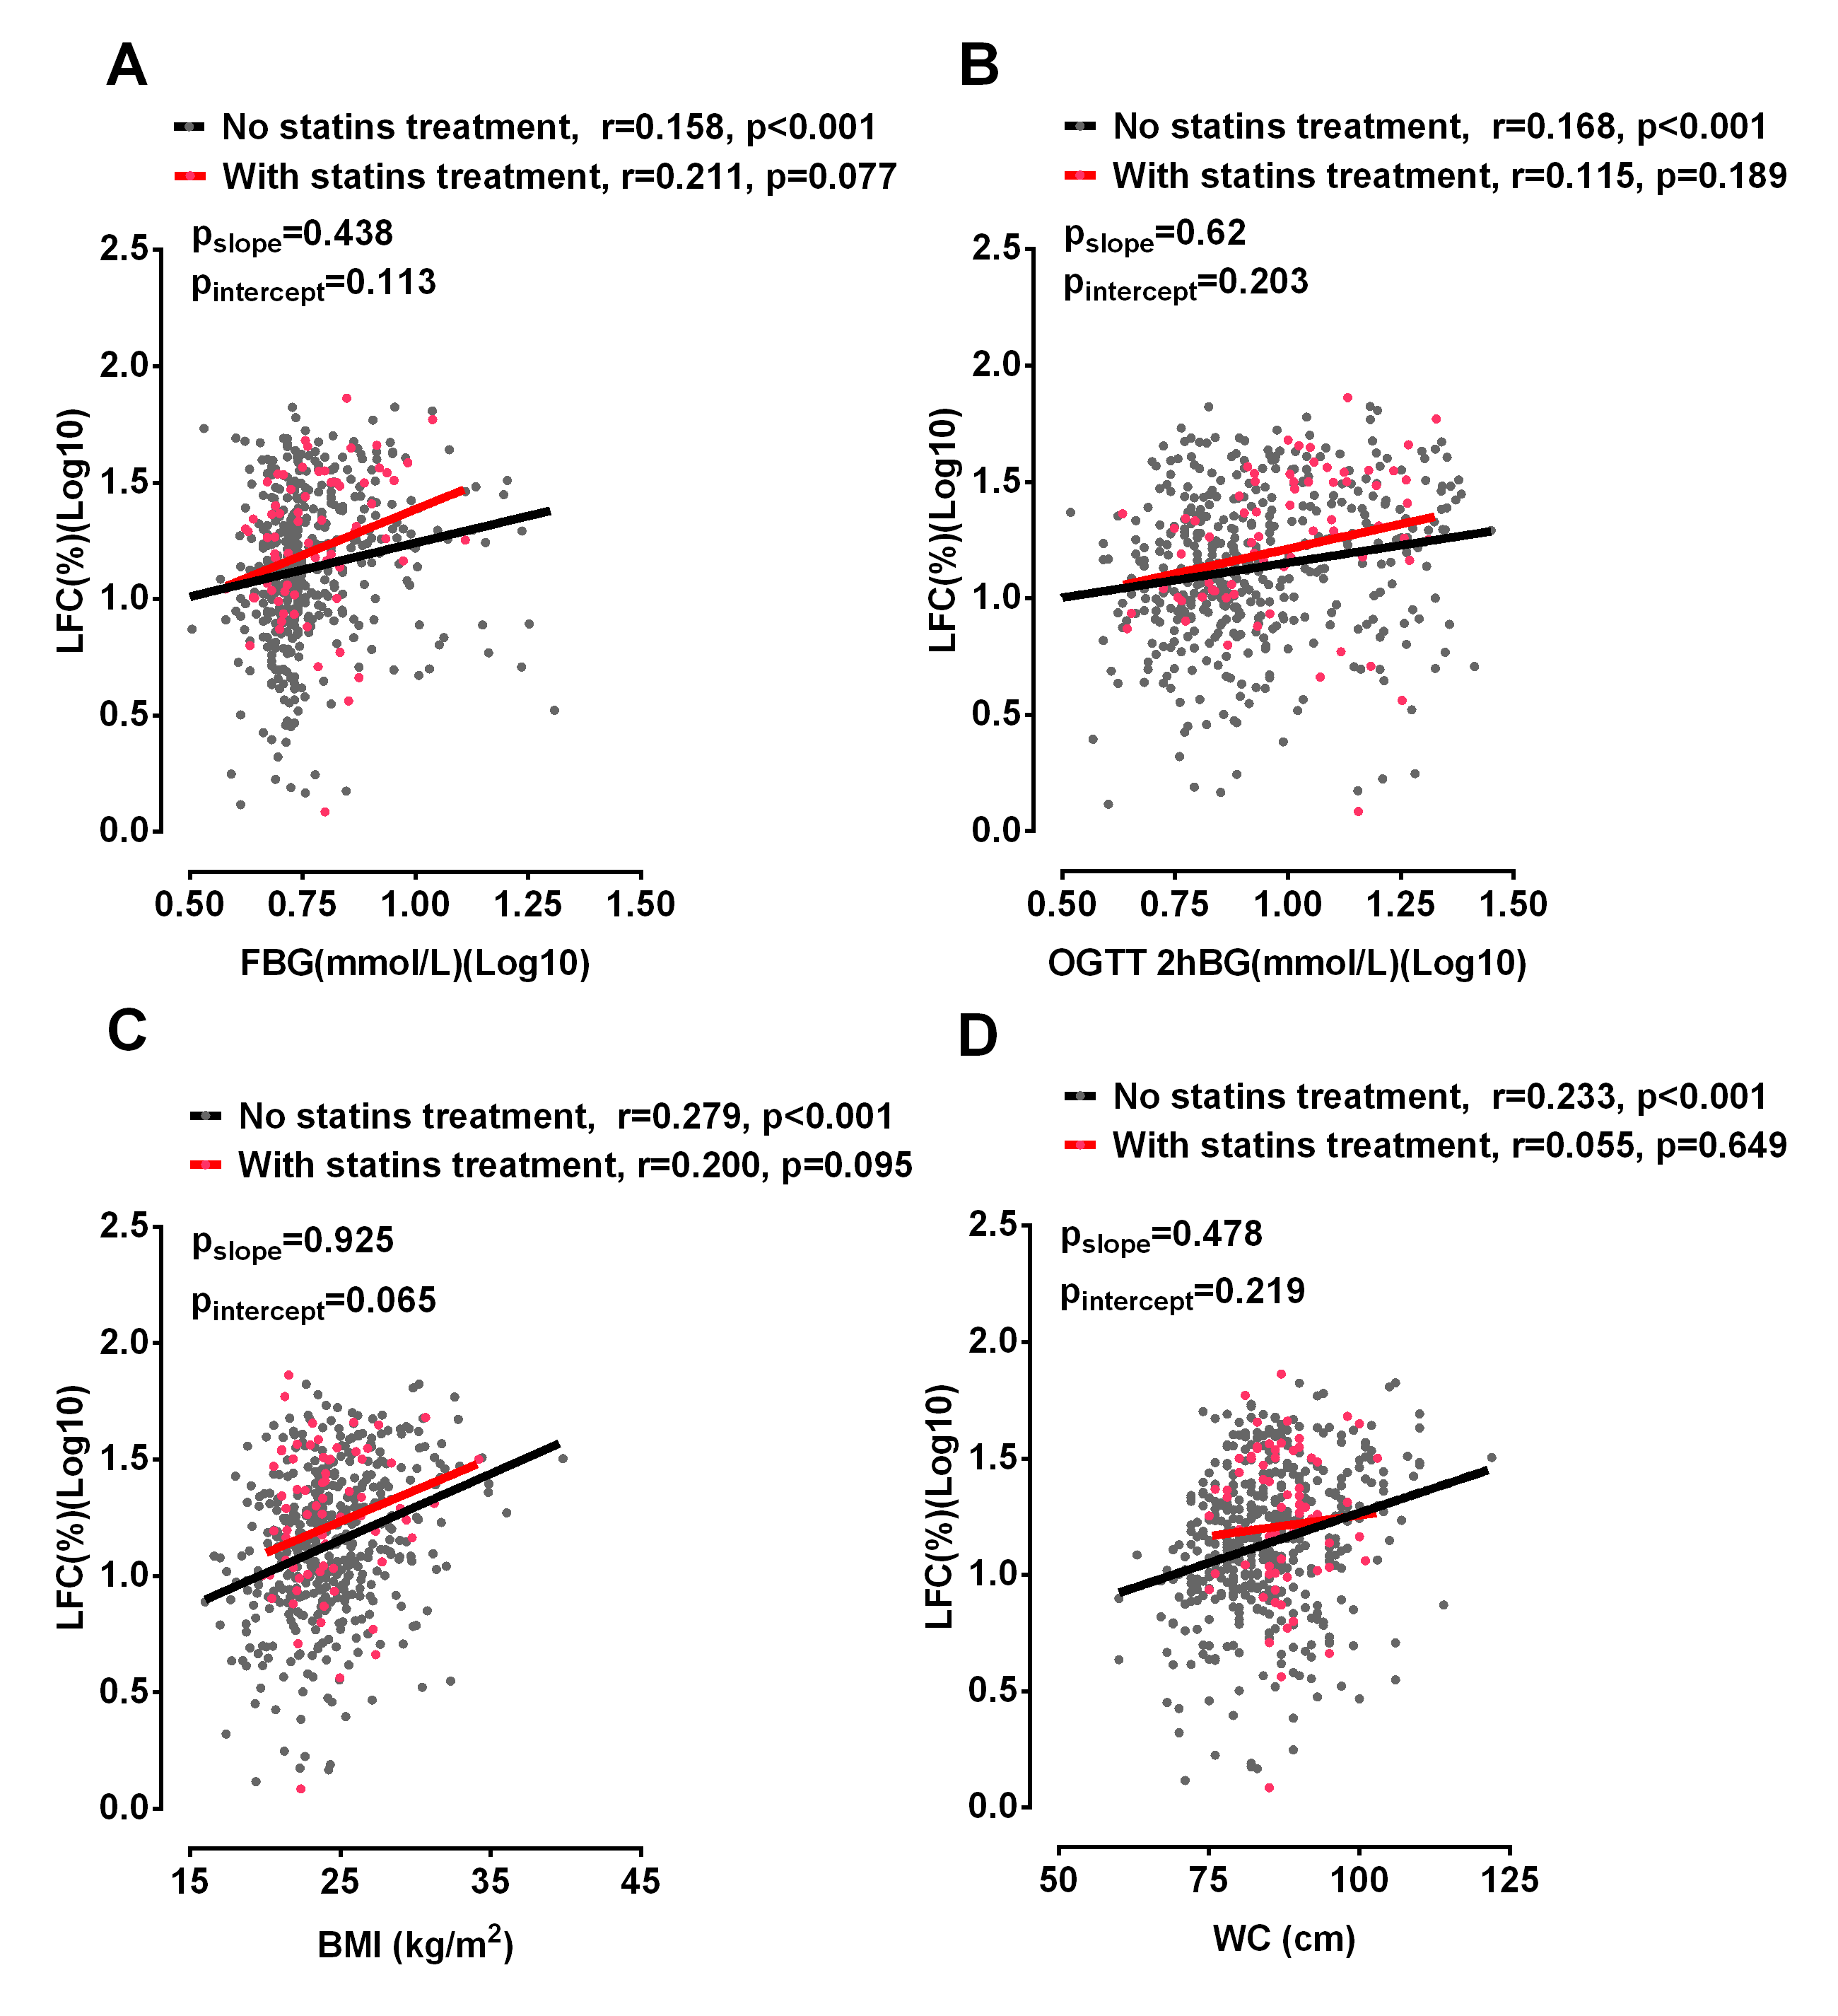

**Supplementary Figure 5. Relationships of LFC (%) with FBG (A), OGTT-2hBG (B), BMI (C) and WC (D) in participants with and without previous statins treatment from the North group (Tianjin, Shandong and Heilongjiang Province).** There were no differences between the slopes or the intercepts of the regression lines relating FBG, OGTT 2hBG, BMI and WC to LFC (p >0.05). Black dots and lines represent participants without statins treatment. Red dots and lines represent participants with statins treatment. Abbreviations: BMI, body mass index; WC, waist circumference; FBG, fasting blood glucose; LFC, liver fat content; OGTT 2hBG, 2-hour postload blood glucose in oral glucose tolerance test.